HandsOn1
Pom.xml
<?xml version="1.0" encoding="UTF-8"?>
<project xmlns="http://maven.apache.org/POM/4.0.0" xmlns:xsi="http://www.w3.org/2001/XMLSchema-instance"
xsi:schemaLocation="http://maven.apache.org/POM/4.0.0 https://maven.apache.org/xsd/maven-4.0.0.xsd">
<modelVersion>4.0.0</modelVersion>
<parent>
<groupId>org.springframework.boot</groupId>
<artifactId>spring-boot-starter-parent</artifactId>
<version>3.5.16</version>
<relativePath/> <!-- lookup parent from repository -->
</parent>
<groupId>com.cognizant</groupId>
<artifactId>orm-learn</artifactId>
<version>0.0.1-SNAPSHOT</version>
<name/>
<description/>
<url/>
<licenses>
<license/>
</licenses>
<developers>
<developer/>
</developers>
<scm>
<connection/>
<developerConnection/>
<tag/>
<url/>
</scm>
<properties>
<java.version>17</java.version>
</properties>
<dependencies>
<dependency>
<groupId>org.springframework.boot</groupId>
<artifactId>spring-boot-starter-data-jpa</artifactId>
</dependency>
<dependency>
<groupId>org.springframework.boot</groupId>
<artifactId>spring-boot-starter-web</artifactId>
</dependency>
<dependency>
<groupId>com.mysql</groupId>
<artifactId>mysql-connector-j</artifactId>
<scope>runtime</scope>
</dependency>
<dependency>
<groupId>org.projectlombok</groupId>
<artifactId>lombok</artifactId>
<optional>true</optional>
</dependency>
<dependency>
<groupId>org.springframework.boot</groupId>
<artifactId>spring-boot-starter-test</artifactId>
<scope>test</scope>
</dependency>
</dependencies>
<build>
<plugins>
<plugin>
<groupId>org.springframework.boot</groupId>
<artifactId>spring-boot-maven-plugin</artifactId>
<configuration>
<excludes>
<exclude>
<groupId>org.projectlombok</groupId>
<artifactId>lombok</artifactId>
</exclude>
</excludes>
</configuration>
</plugin>
<plugin>
<groupId>org.apache.maven.plugins</groupId>
<artifactId>maven-compiler-plugin</artifactId>
<executions>
<execution>
<id>default-compile</id>
<phase>compile</phase>
<goals>
<goal>compile</goal>
</goals>
<configuration>
<annotationProcessorPaths>
<path>
<groupId>org.projectlombok</groupId>
<artifactId>lombok</artifactId>
</path>
</annotationProcessorPaths>
</configuration>
</execution>
<execution>
<id>default-testCompile</id>
<phase>test-compile</phase>
<goals>
<goal>testCompile</goal>
</goals>
<configuration>
<annotationProcessorPaths>
<path>
<groupId>org.projectlombok</groupId>
<artifactId>lombok</artifactId>
</path>
</annotationProcessorPaths>
</configuration>
</execution>
</executions>
</plugin>
</plugins>
</build>
</project>

Country.java
package com.cognizant.ormlearn.model;
import jakarta.persistence.Column;
import jakarta.persistence.Entity;
import jakarta.persistence.Id;
import jakarta.persistence.Table;
@Entity
@Table(name = "country")
public class Country {
@Id
@Column(name = "co_code")
private String code;
@Column(name = "co_name")
private String name;
public Country() {
}
public Country(String code, String name) {
this.code = code;
this.name = name;
}
public String getCode() {
return code;
}
public void setCode(String code) {
this.code = code;
}
public String getName() {
return name;
}
public void setName(String name) {
this.name = name;
}
@Override
public String toString() {
return code + " " + name;
}
}

CountryRepository.java
package com.cognizant.ormlearn.repository;
import com.cognizant.ormlearn.model.Country;
import org.springframework.data.jpa.repository.JpaRepository;
import java.util.List;
public interface CountryRepository extends JpaRepository<Country, String> {
List<Country> findByNameContaining(String text);
List<Country> findByNameContainingOrderByNameAsc(String text);
List<Country> findByNameStartingWith(String alphabet);
}

OrmLearnApplication.java
package com.cognizant.ormlearn;
import com.cognizant.ormlearn.repository.CountryRepository;
import org.springframework.boot.CommandLineRunner;
import org.springframework.boot.SpringApplication;
import org.springframework.boot.autoconfigure.SpringBootApplication;
import org.springframework.context.annotation.Bean;
@SpringBootApplication
public class OrmLearnApplication {
public static void main(String[] args) {
SpringApplication.run(OrmLearnApplication.class, args);
}
@Bean
CommandLineRunner testCountry(CountryRepository repository) {
return args -> {
System.out.println("Countries containing 'ou':");
repository.findByNameContaining("ou")
.forEach(System.out::println);
System.out.println("\nCountries containing 'ou' in ascending order:");
repository.findByNameContainingOrderByNameAsc("ou")
.forEach(System.out::println);
System.out.println("\nCountries starting with 'Z':");
repository.findByNameStartingWith("Z")
.forEach(System.out::println);
};
}
}

Output
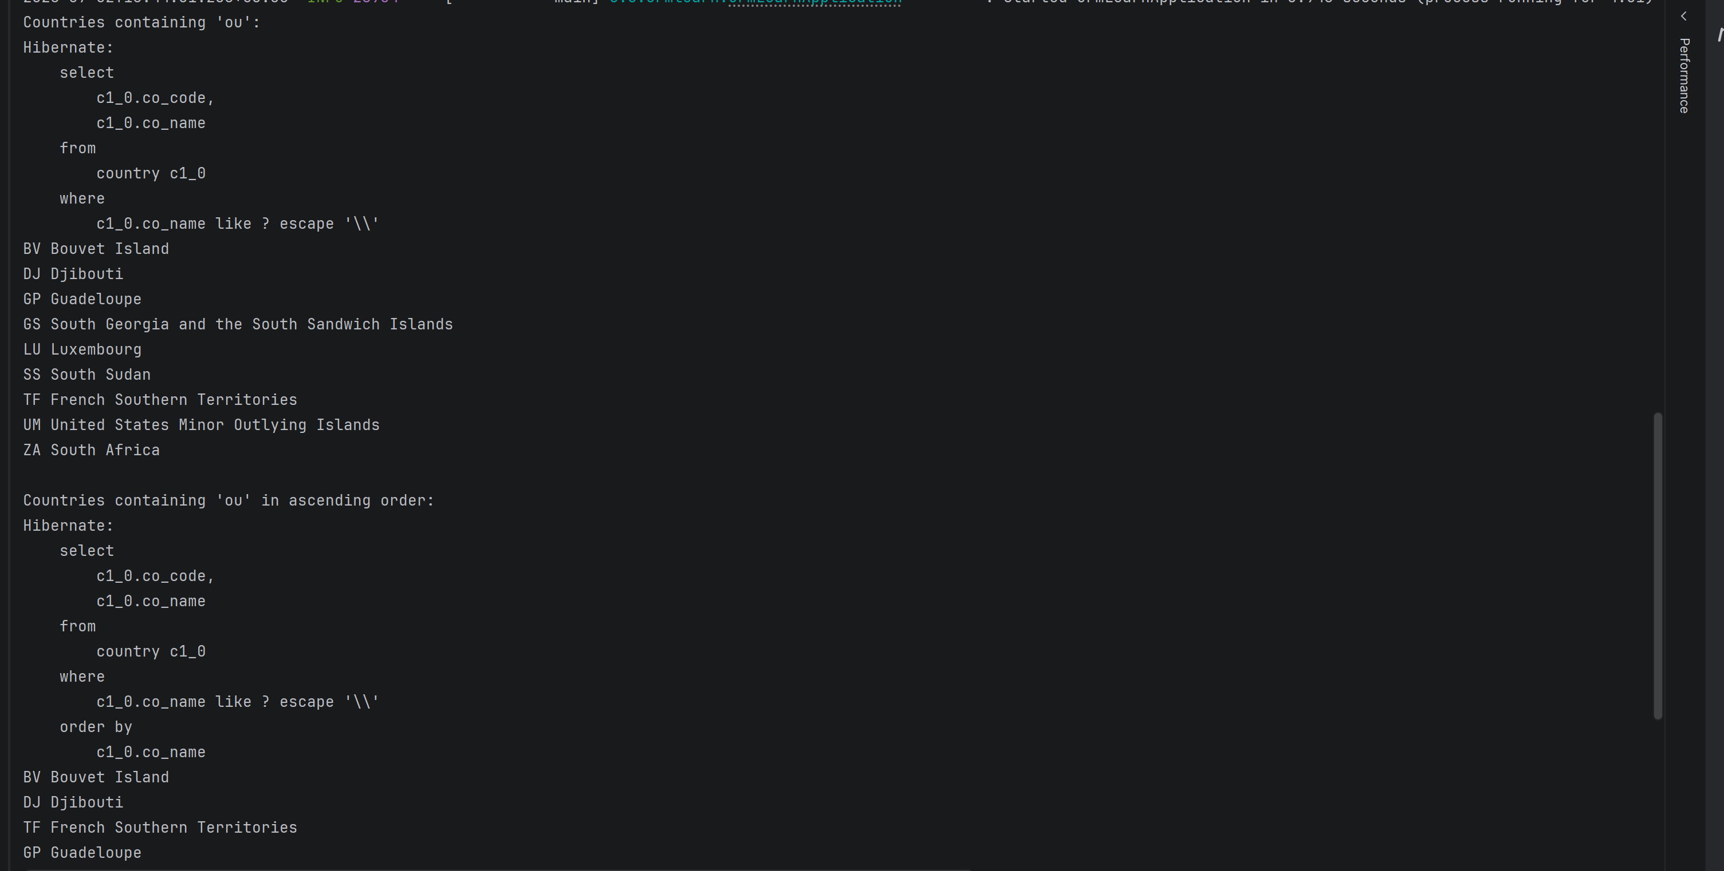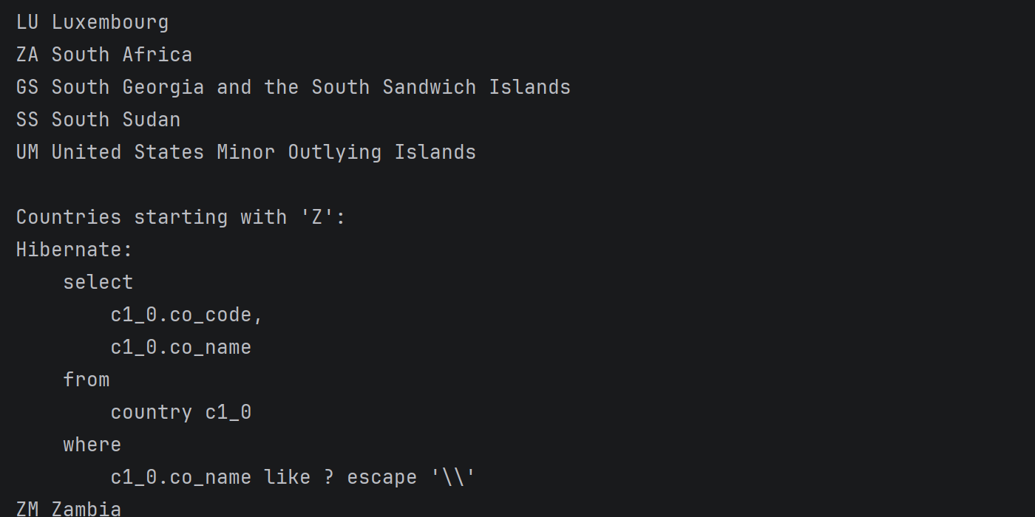

HandsOn2
Stock.java
package com.cognizant.ormlearn.model;
import jakarta.persistence.*;
import java.math.BigDecimal;
import java.time.LocalDate;
@Entity
@Table(name = "stock")
public class Stock {
@Id
@GeneratedValue(strategy = GenerationType.IDENTITY)
@Column(name = "st_id")
private Integer id;
@Column(name = "st_code")
private String code;
@Column(name = "st_date")
private LocalDate date;
@Column(name = "st_open")
private BigDecimal open;
@Column(name = "st_close")
private BigDecimal close;
@Column(name = "st_volume")
private Long volume;
public Stock() {
}
public Integer getId() {
return id;
}
public void setId(Integer id) {
this.id = id;
}
public String getCode() {
return code;
}
public void setCode(String code) {
this.code = code;
}
public LocalDate getDate() {
return date;
}
public void setDate(LocalDate date) {
this.date = date;
}
public BigDecimal getOpen() {
return open;
}
public void setOpen(BigDecimal open) {
this.open = open;
}
public BigDecimal getClose() {
return close;
}
public void setClose(BigDecimal close) {
this.close = close;
}
public Long getVolume() {
return volume;
}
public void setVolume(Long volume) {
this.volume = volume;
}
@Override
public String toString() {
return "Stock{" +
"id=" + id +
", code='" + code + '\'' +
", date=" + date +
", open=" + open +
", close=" + close +
", volume=" + volume +
'}';
}
}

StockRepository.java
package com.cognizant.ormlearn.repository;
import com.cognizant.ormlearn.model.Stock;
import org.springframework.data.jpa.repository.JpaRepository;
import java.math.BigDecimal;
import java.time.LocalDate;
import java.util.List;
public interface StockRepository extends JpaRepository<Stock, Integer> {
List<Stock> findByCodeAndDateBetween(
String code,
LocalDate startDate,
LocalDate endDate);
List<Stock> findByCodeAndCloseGreaterThan(
String code,
BigDecimal close);
List<Stock> findTop3ByOrderByVolumeDesc();
List<Stock> findTop3ByCodeOrderByCloseAsc(String code);
}

OrmLearnApplication
package com.cognizant.ormlearn;
import com.cognizant.ormlearn.repository.CountryRepository;
import com.cognizant.ormlearn.repository.StockRepository;
import org.springframework.boot.CommandLineRunner;
import org.springframework.boot.SpringApplication;
import org.springframework.boot.autoconfigure.SpringBootApplication;
import org.springframework.context.annotation.Bean;
import java.math.BigDecimal;
import java.time.LocalDate;
@SpringBootApplication
public class OrmLearnApplication {
public static void main(String[] args) {
SpringApplication.run(OrmLearnApplication.class, args);
}
@Bean
CommandLineRunner testCountry(CountryRepository repository) {
return args -> {
System.out.println("Countries containing 'ou':");
repository.findByNameContaining("ou")
.forEach(System.out::println);
System.out.println("\nCountries containing 'ou' in ascending order:");
repository.findByNameContainingOrderByNameAsc("ou")
.forEach(System.out::println);
System.out.println("\nCountries starting with 'Z':");
repository.findByNameStartingWith("Z")
.forEach(System.out::println);
};
}
@Bean
CommandLineRunner testStock(StockRepository repository) {
return args -> {
System.out.println("\n========== FACEBOOK ==========");
repository.findByCodeAndDateBetween(
"FB",
LocalDate.of(2019, 9, 1),
LocalDate.of(2019, 9, 30))
.forEach(System.out::println);
System.out.println("\n========== GOOGLE ==========");
repository.findByCodeAndCloseGreaterThan(
"GOOGL",
new BigDecimal("1250"))
.forEach(System.out::println);
System.out.println("\n========== TOP 3 VOLUME ==========");
repository.findTop3ByOrderByVolumeDesc()
.forEach(System.out::println);
System.out.println("\n========== NETFLIX ==========");
repository.findTop3ByCodeOrderByCloseAsc("NFLX")
.forEach(System.out::println);
};
}
}

Output
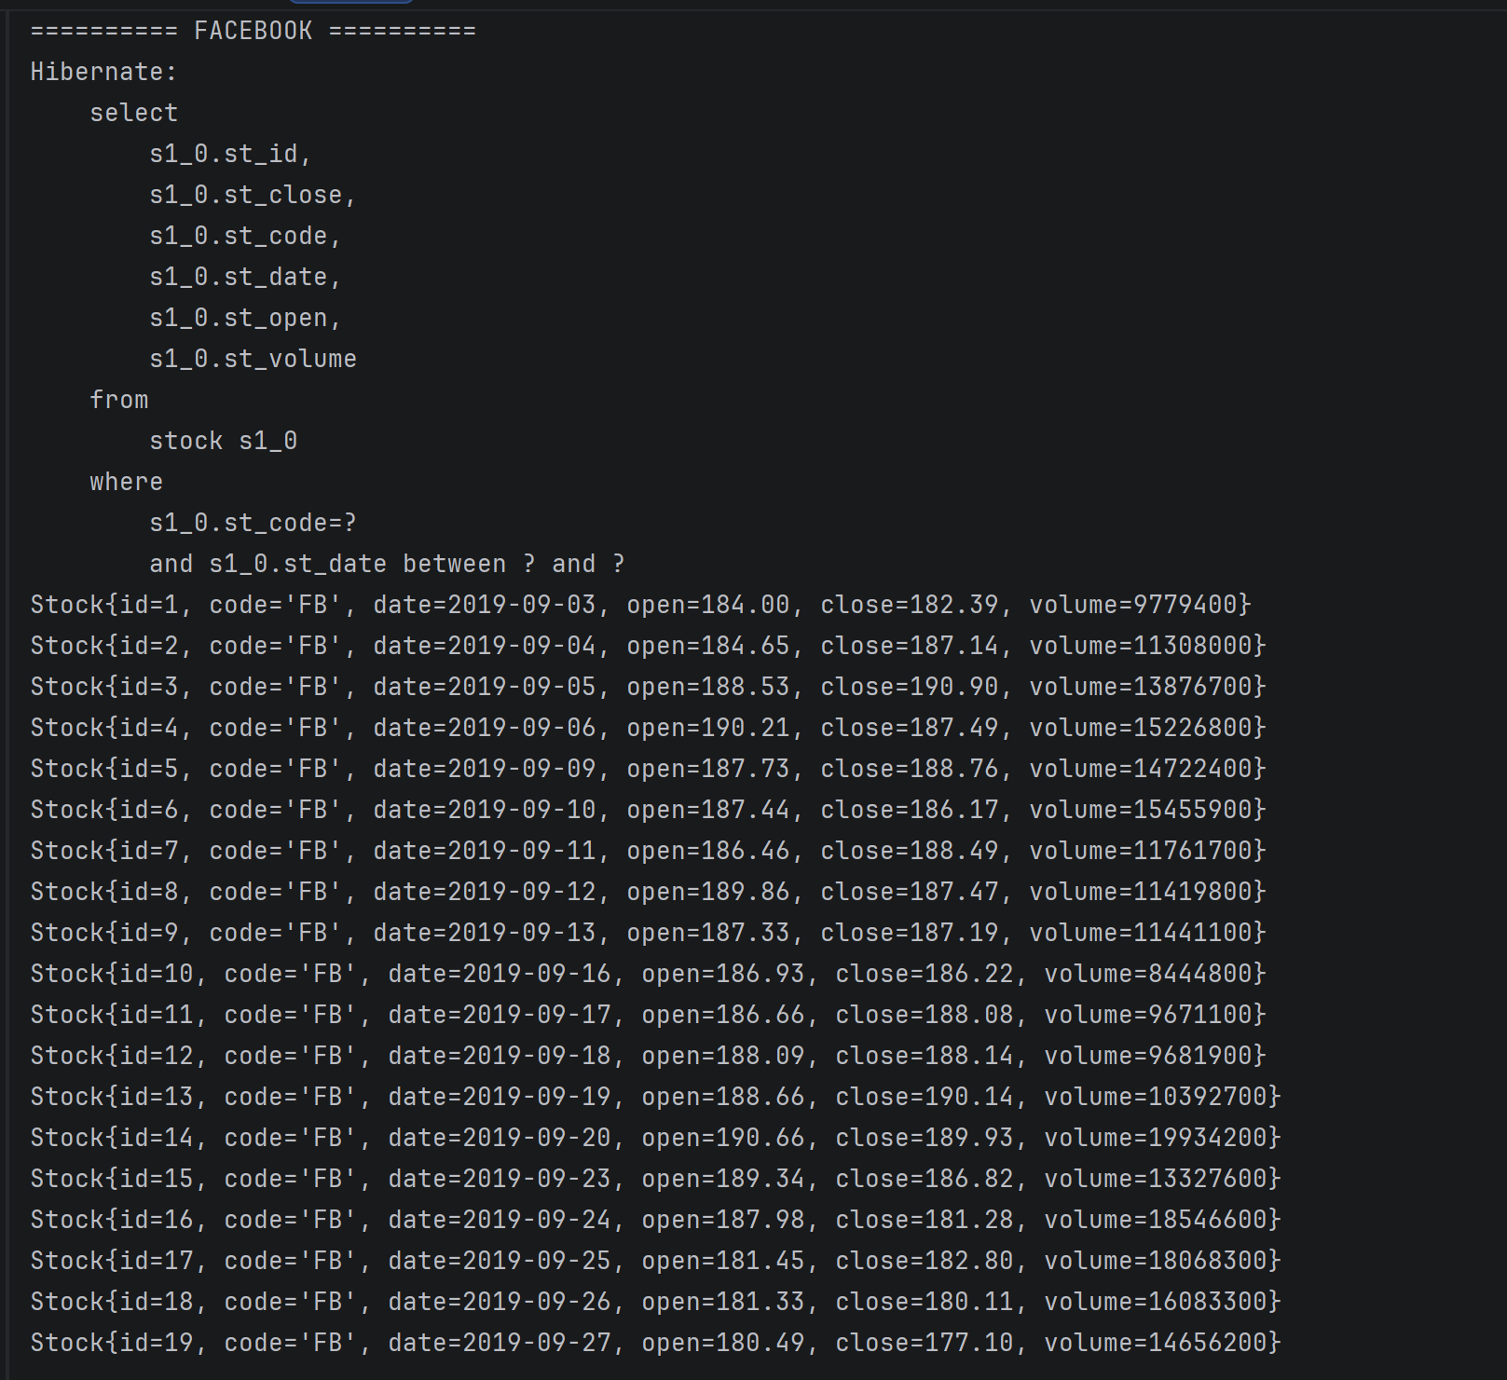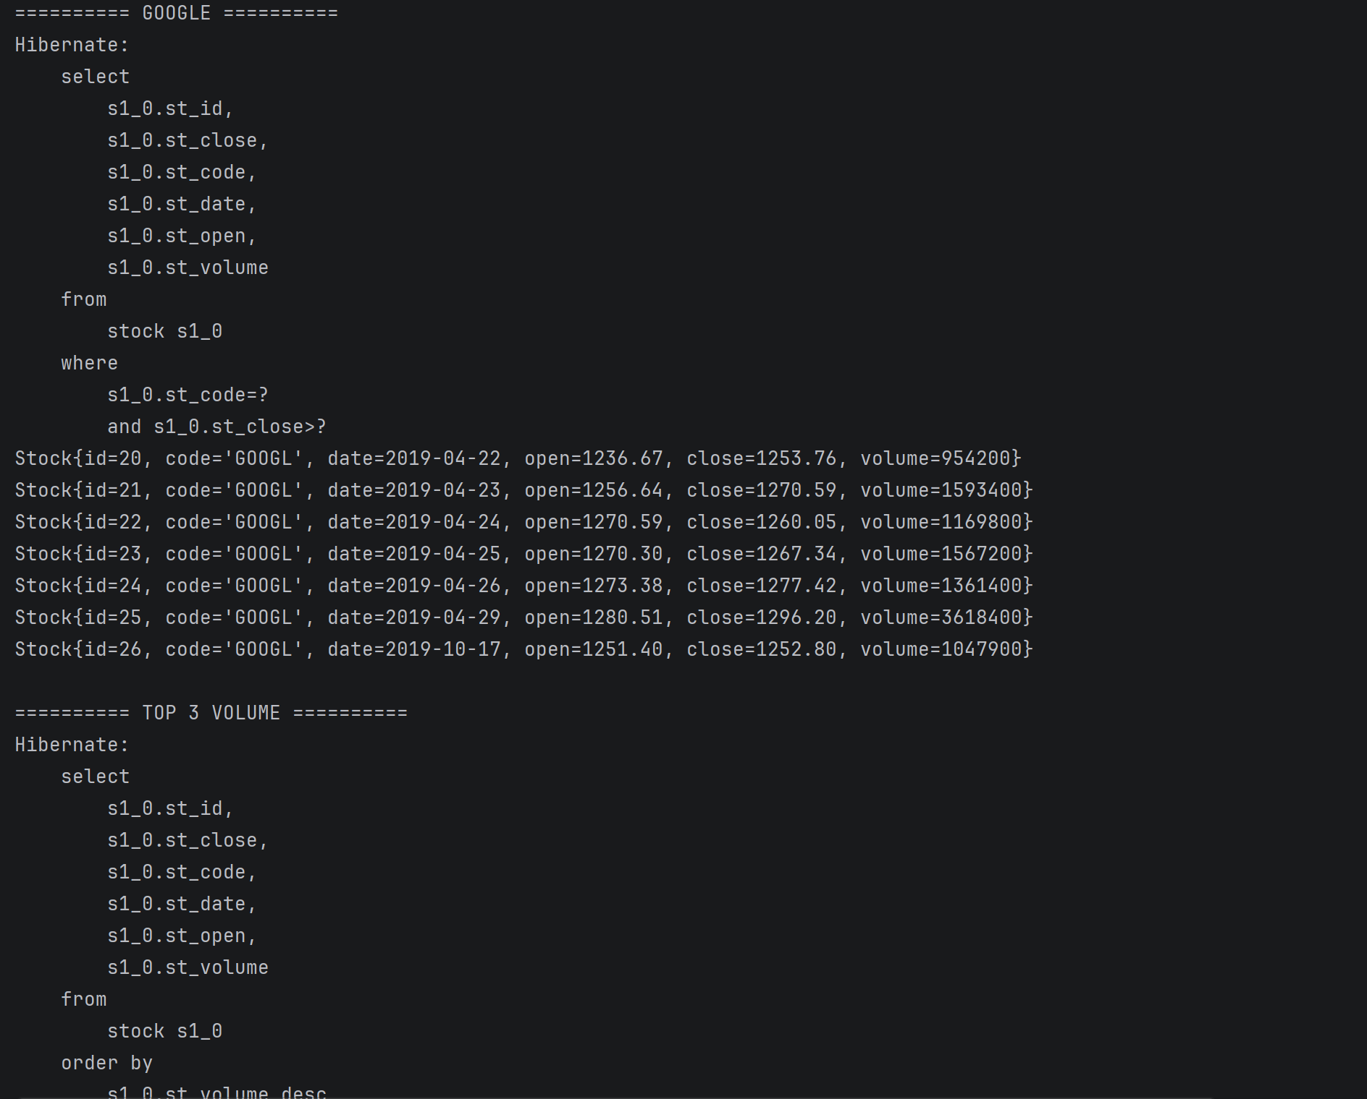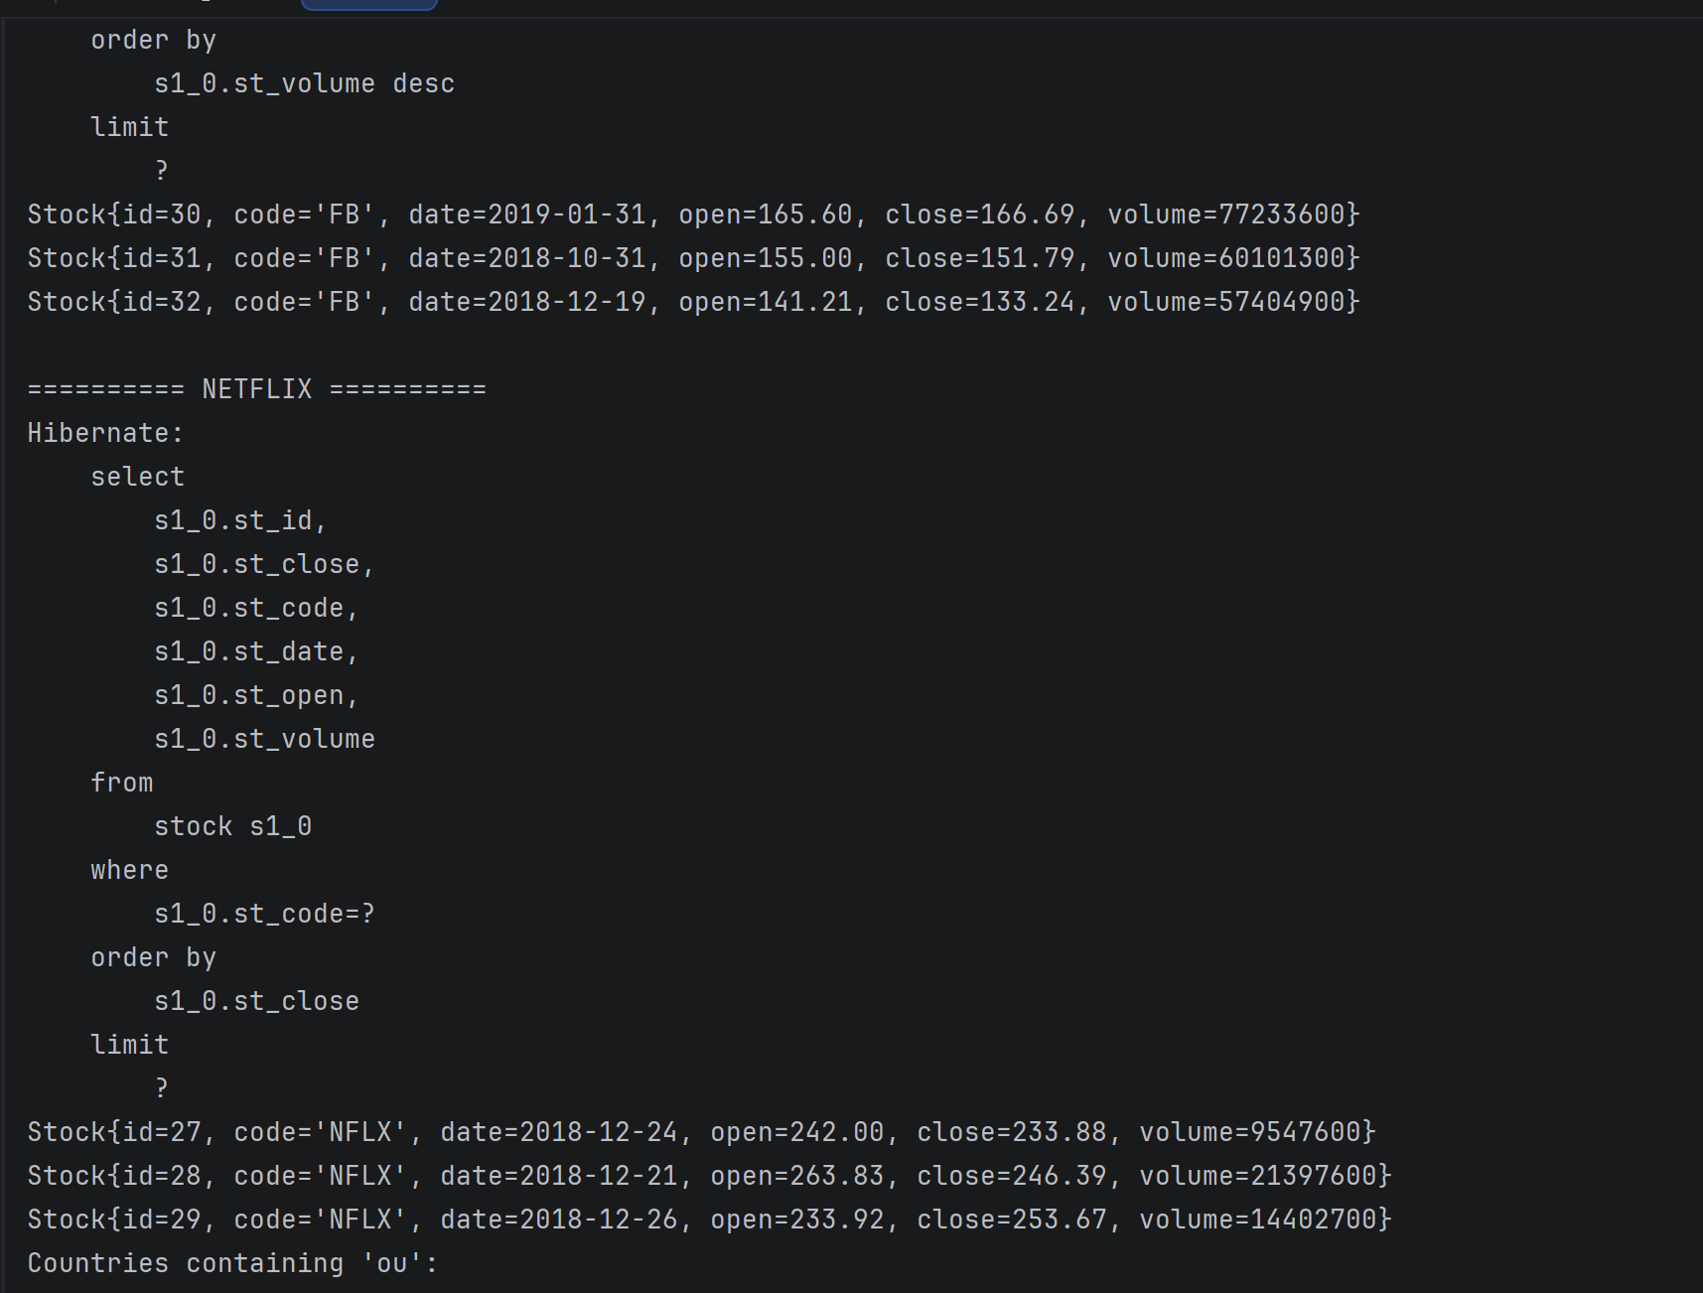
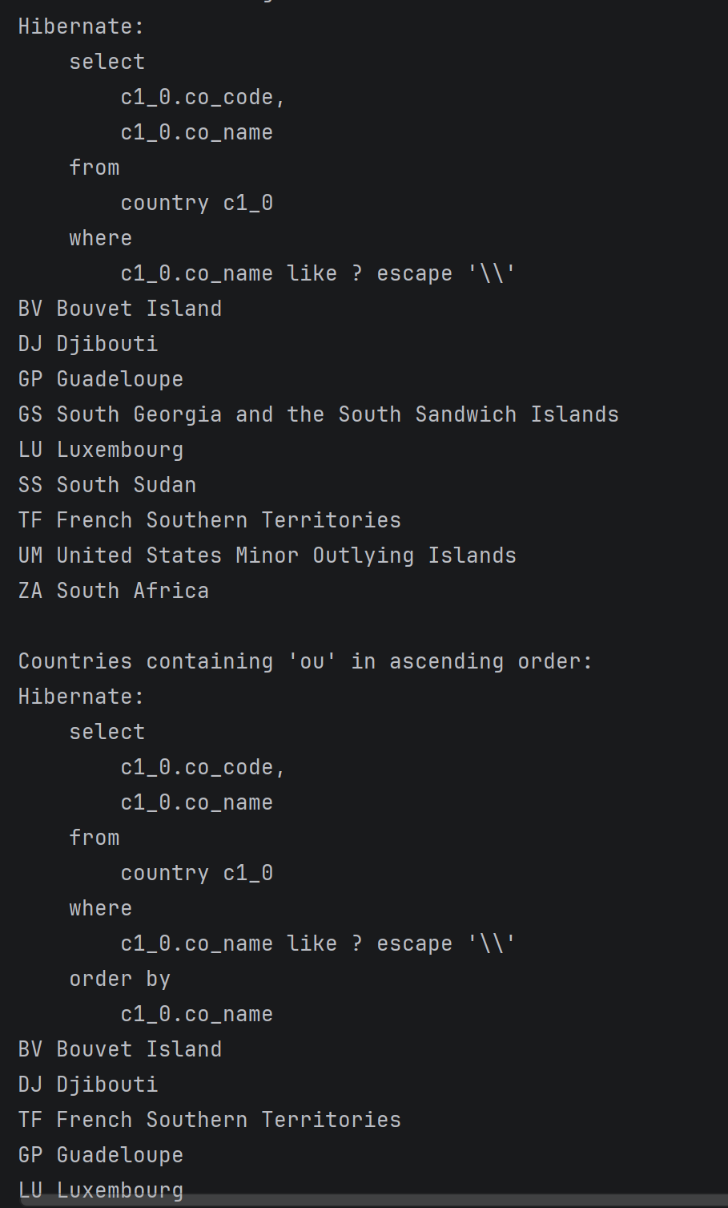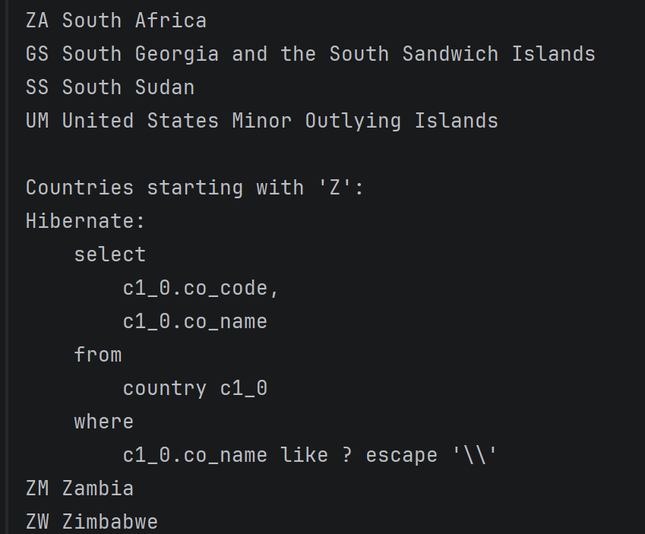
HandsOn3
Department.java
package com.cognizant.ormlearn.model;
import jakarta.persistence.*;
@Entity
@Table(name = "department")
public class Department {
@Id
@GeneratedValue(strategy = GenerationType.IDENTITY)
@Column(name = "dp_id")
private int id;
@Column(name = "dp_name")
private String name;
public Department() {
}
public int getId() {
return id;
}
public void setId(int id) {
this.id = id;
}
public String getName() {
return name;
}
public void setName(String name) {
this.name = name;
}
@Override
public String toString() {
return "Department{" +
"id=" + id +
", name='" + name + '\'' +
'}';
}
}

Employee.java
package com.cognizant.ormlearn.model;
import jakarta.persistence.*;
import java.util.Date;
@Entity
@Table(name = "employee")
public class Employee {
@Id
@GeneratedValue(strategy = GenerationType.IDENTITY)
@Column(name = "em_id")
private int id;
@Column(name = "em_name")
private String name;
@Column(name = "em_salary")
private double salary;
@Column(name = "em_permanent")
private boolean permanent;
@Temporal(TemporalType.DATE)
@Column(name = "em_date_of_birth")
private Date dateOfBirth;
public Employee() {
}
public int getId() {
return id;
}
public void setId(int id) {
this.id = id;
}
public String getName() {
return name;
}
public void setName(String name) {
this.name = name;
}
public double getSalary() {
return salary;
}
public void setSalary(double salary) {
this.salary = salary;
}
public boolean isPermanent() {
return permanent;
}
public void setPermanent(boolean permanent) {
this.permanent = permanent;
}
public Date getDateOfBirth() {
return dateOfBirth;
}
public void setDateOfBirth(Date dateOfBirth) {
this.dateOfBirth = dateOfBirth;
}
@Override
public String toString() {
return "Employee{" +
"id=" + id +
", name='" + name + '\'' +
", salary=" + salary +
", permanent=" + permanent +
", dateOfBirth=" + dateOfBirth +
'}';
}
}

Skill.java
package com.cognizant.ormlearn.model;
import jakarta.persistence.*;
@Entity
@Table(name = "skill")
public class Skill {
@Id
@GeneratedValue(strategy = GenerationType.IDENTITY)
@Column(name = "sk_id")
private int id;
@Column(name = "sk_name")
private String name;
public Skill() {
}
public int getId() {
return id;
}
public void setId(int id) {
this.id = id;
}
public String getName() {
return name;
}
public void setName(String name) {
this.name = name;
}
@Override
public String toString() {
return "Skill{" +
"id=" + id +
", name='" + name + '\'' +
'}';
}
}

DepartmentRepository.java
package com.cognizant.ormlearn.repository;
import com.cognizant.ormlearn.model.Department;
import org.springframework.data.jpa.repository.JpaRepository;
public interface DepartmentRepository extends JpaRepository<Department, Integer> {
}

EmployeeRepository.java
package com.cognizant.ormlearn.repository;
import com.cognizant.ormlearn.model.Employee;
import org.springframework.data.jpa.repository.JpaRepository;
public interface EmployeeRepository extends JpaRepository<Employee, Integer> {
}

SkillRepository.java
package com.cognizant.ormlearn.repository;
import com.cognizant.ormlearn.model.Skill;
import org.springframework.data.jpa.repository.JpaRepository;
public interface SkillRepository extends JpaRepository<Skill, Integer> {
}

HandsOn4
DepartmentService.java
package com.cognizant.ormlearn.service;
import com.cognizant.ormlearn.model.Department;
import com.cognizant.ormlearn.repository.DepartmentRepository;
import jakarta.transaction.Transactional;
import org.springframework.beans.factory.annotation.Autowired;
import org.springframework.stereotype.Service;
@Service
public class DepartmentService {
@Autowired
private DepartmentRepository departmentRepository;
@Transactional
public Department get(int id){
return departmentRepository.findById(id).get();
}
@Transactional
public void save(Department department){
departmentRepository.save(department);
}
}

EmployeeService.java
package com.cognizant.ormlearn.service;
import com.cognizant.ormlearn.model.Employee;
import com.cognizant.ormlearn.repository.EmployeeRepository;
import jakarta.transaction.Transactional;
import org.springframework.beans.factory.annotation.Autowired;
import org.springframework.stereotype.Service;
@Service
public class EmployeeService {
@Autowired
private EmployeeRepository employeeRepository;
@Transactional
public Employee get(int id){
return employeeRepository.findById(id).get();
}
@Transactional
public void save(Employee employee){
employeeRepository.save(employee);
}
}

SkillService.java
package com.cognizant.ormlearn.service;
import com.cognizant.ormlearn.model.Skill;
import com.cognizant.ormlearn.repository.SkillRepository;
import jakarta.transaction.Transactional;
import org.springframework.beans.factory.annotation.Autowired;
import org.springframework.stereotype.Service;
@Service
public class SkillService {
@Autowired
private SkillRepository skillRepository;
@Transactional
public Skill get(int id){
return skillRepository.findById(id).get();
}
@Transactional
public void save(Skill skill){
skillRepository.save(skill);
}
}

OrmLearnApplication
package com.cognizant.ormlearn;
import com.cognizant.ormlearn.model.Department;
import com.cognizant.ormlearn.model.Employee;
import com.cognizant.ormlearn.repository.CountryRepository;
import com.cognizant.ormlearn.repository.StockRepository;
import com.cognizant.ormlearn.service.DepartmentService;
import com.cognizant.ormlearn.service.EmployeeService;
import com.cognizant.ormlearn.service.SkillService;
import org.springframework.beans.factory.annotation.Autowired;
import org.springframework.boot.CommandLineRunner;
import org.springframework.boot.SpringApplication;
import org.springframework.boot.autoconfigure.SpringBootApplication;
import org.springframework.context.annotation.Bean;
import java.math.BigDecimal;
import java.time.LocalDate;
import java.text.SimpleDateFormat;
@SpringBootApplication
public class OrmLearnApplication {
@Autowired
private EmployeeService employeeService;
@Autowired
private DepartmentService departmentService;
@Autowired
private SkillService skillService;
public static void main(String[] args) {
SpringApplication.run(OrmLearnApplication.class, args);
}
@Bean
CommandLineRunner run(CountryRepository countryRepository,
StockRepository stockRepository) {
return args -> {
// ================= HANDS ON 1 =================
System.out.println("\n========== COUNTRY ==========");
System.out.println("\nCountries containing 'ou'");
countryRepository.findByNameContaining("ou")
.forEach(System.out::println);
System.out.println("\nCountries containing 'ou' sorted");
countryRepository.findByNameContainingOrderByNameAsc("ou")
.forEach(System.out::println);
System.out.println("\nCountries starting with 'Z'");
countryRepository.findByNameStartingWith("Z")
.forEach(System.out::println);
// ================= HANDS ON 2 =================
System.out.println("\n========== STOCK ==========");
System.out.println("\nFacebook September Data");
stockRepository.findByCodeAndDateBetween(
"FB",
LocalDate.of(2019,9,1),
LocalDate.of(2019,9,30))
.forEach(System.out::println);
System.out.println("\nGoogle Close >1250");
stockRepository.findByCodeAndCloseGreaterThan(
"GOOGL",
new BigDecimal("1250"))
.forEach(System.out::println);
System.out.println("\nTop 3 Highest Volume");
stockRepository.findTop3ByOrderByVolumeDesc()
.forEach(System.out::println);
System.out.println("\nLowest Netflix");
stockRepository.findTop3ByCodeOrderByCloseAsc("NFLX")
.forEach(System.out::println);
// ================= HANDS ON 4 =================
testGetEmployee();
testAddEmployee();
testUpdateEmployee();
};
}
private void testGetEmployee() {
System.out.println("\n========== GET EMPLOYEE ==========");
Employee employee = employeeService.get(1);
System.out.println(employee);
System.out.println(employee.getDepartment());
}
private void testAddEmployee() throws Exception {
System.out.println("\n========== ADD EMPLOYEE ==========");
Employee employee = new Employee();
employee.setName("Neer");
employee.setSalary(90000);
employee.setPermanent(true);
employee.setDateOfBirth(
new SimpleDateFormat("dd/MM/yyyy")
.parse("10/09/2005"));
Department department = departmentService.get(2);
employee.setDepartment(department);
employeeService.save(employee);
System.out.println(employee);
}
private void testUpdateEmployee() {
System.out.println("\n========== UPDATE EMPLOYEE ==========");
Employee employee = employeeService.get(1);
Department department = departmentService.get(3);
employee.setDepartment(department);
employeeService.save(employee);
System.out.println(employee);
}
}
Output
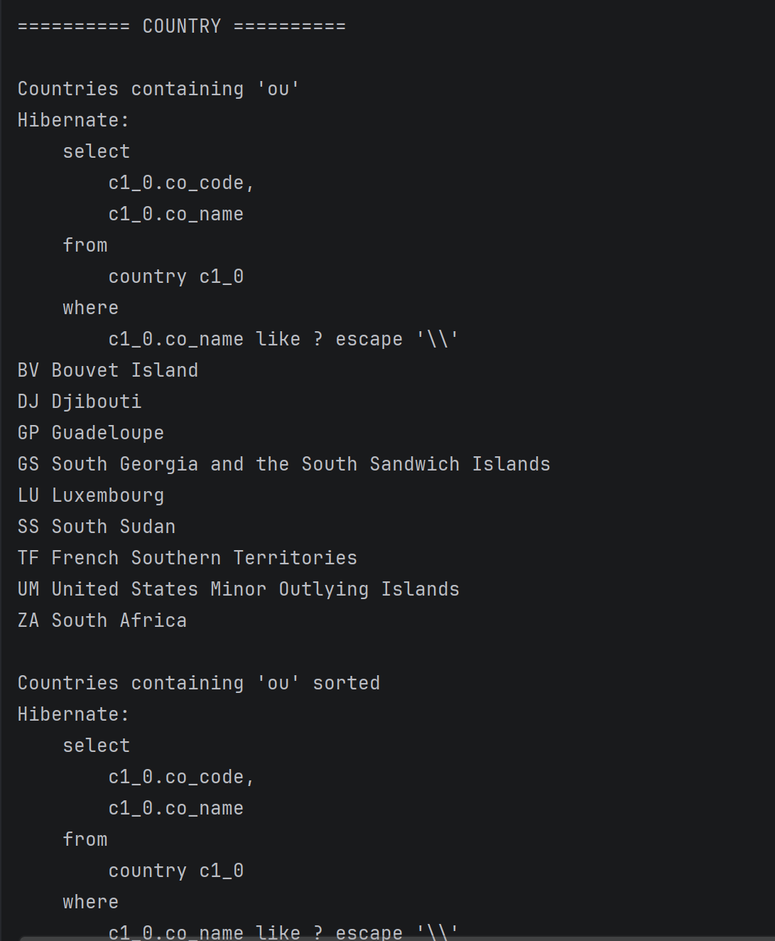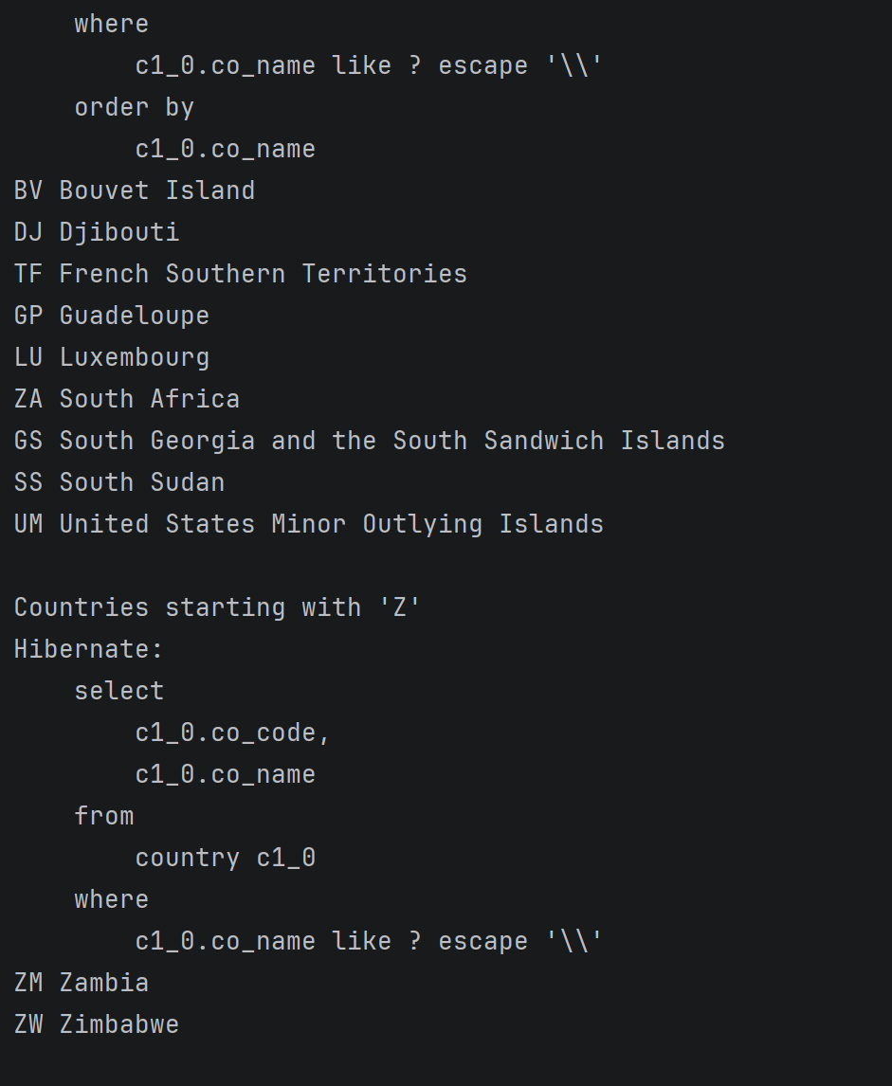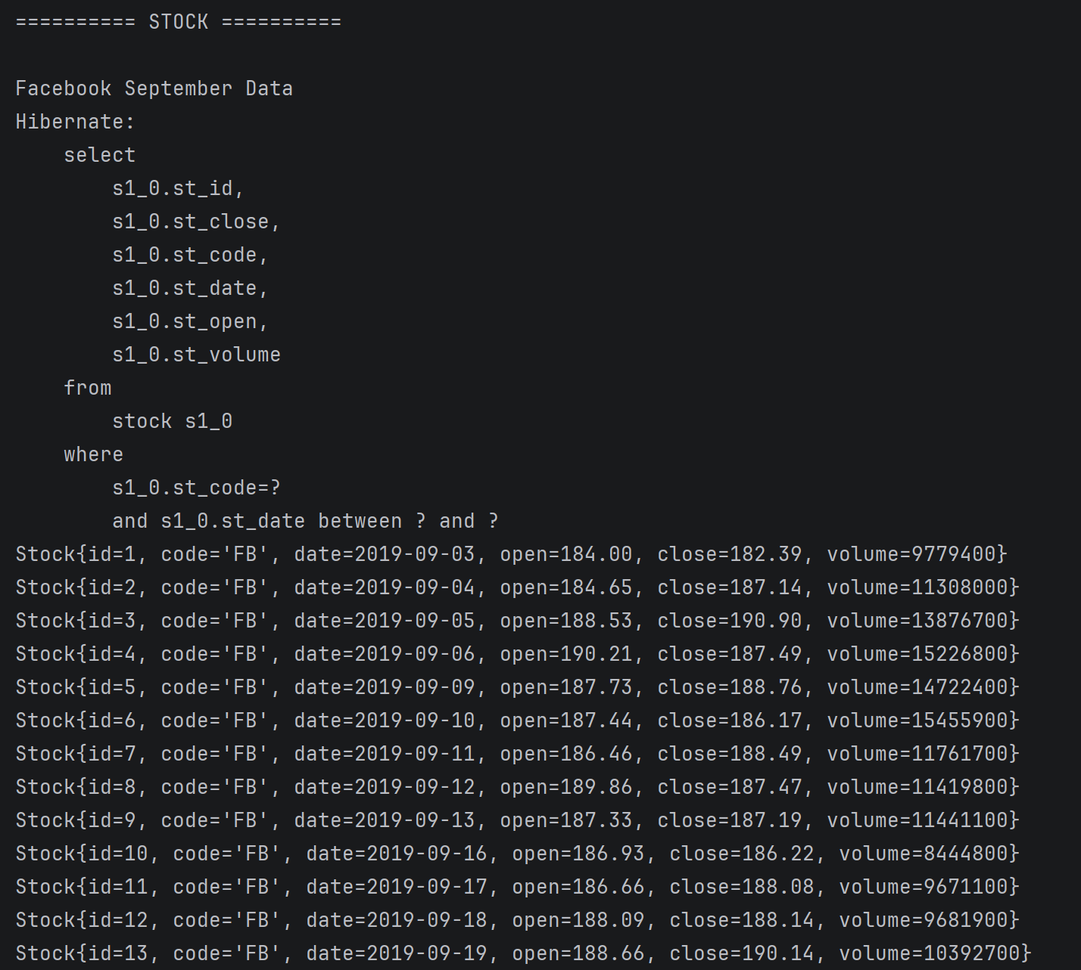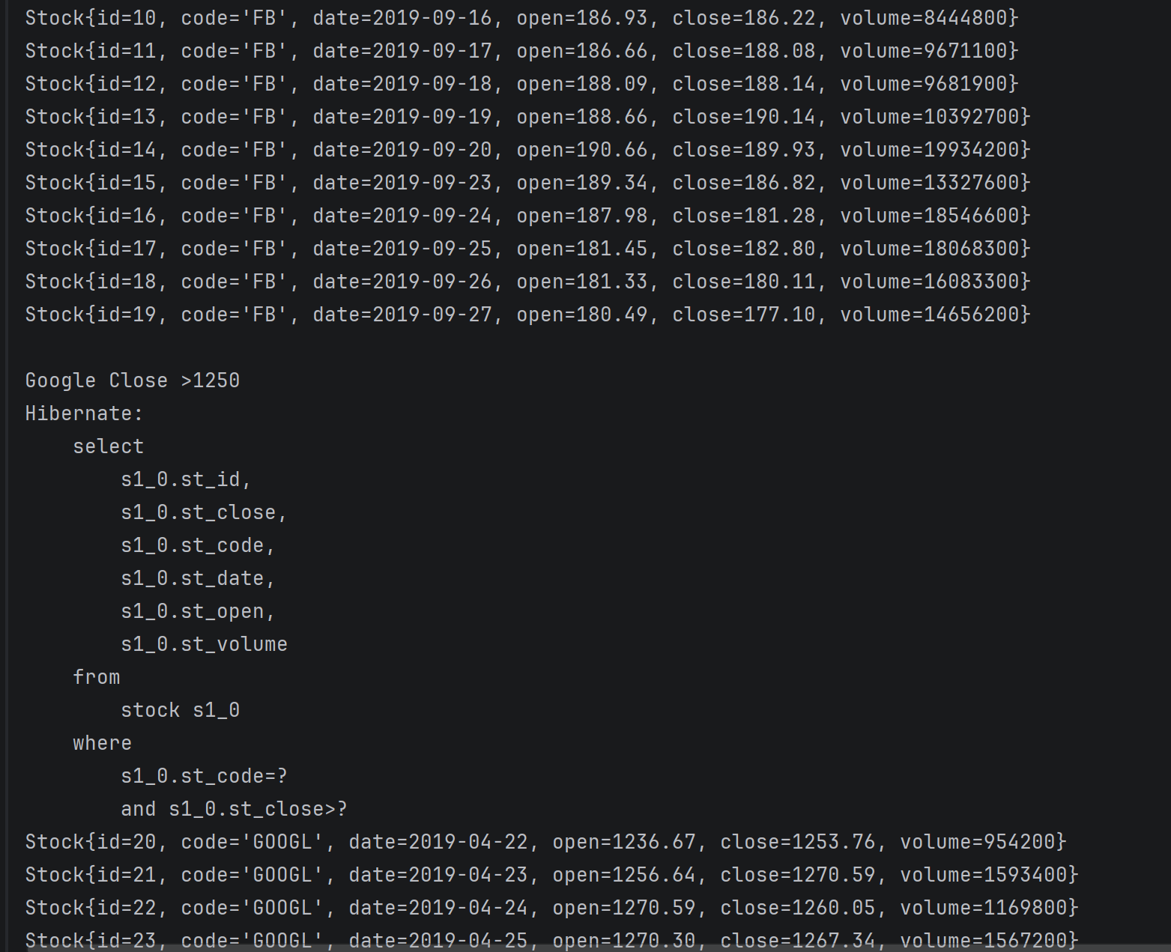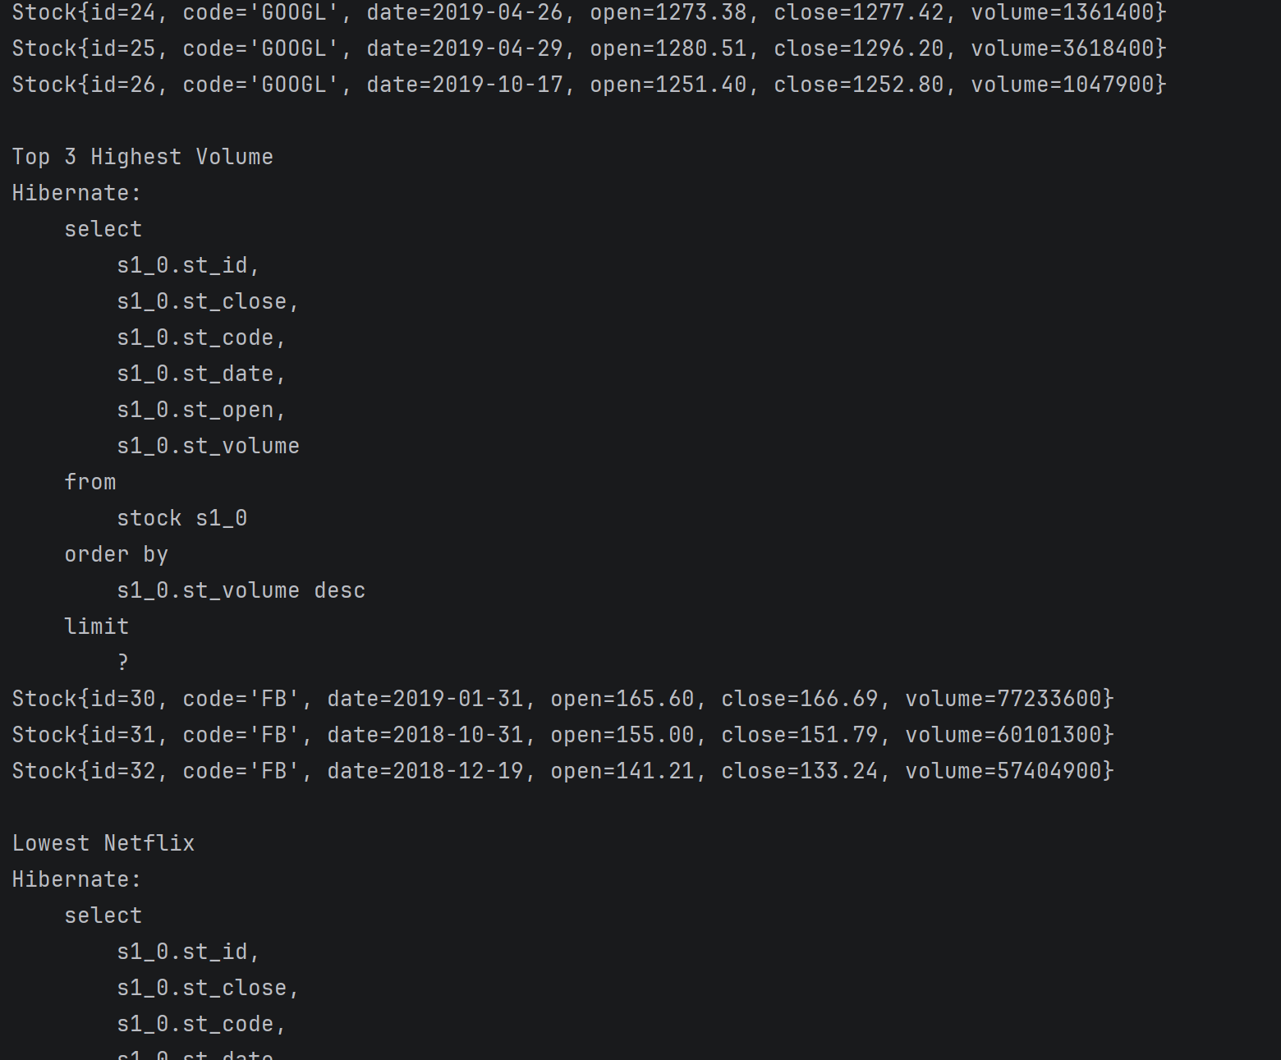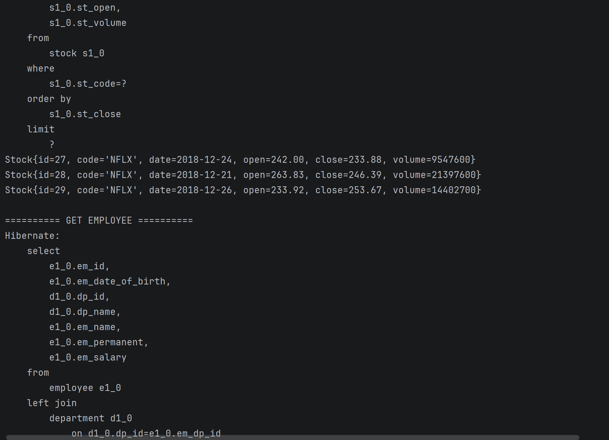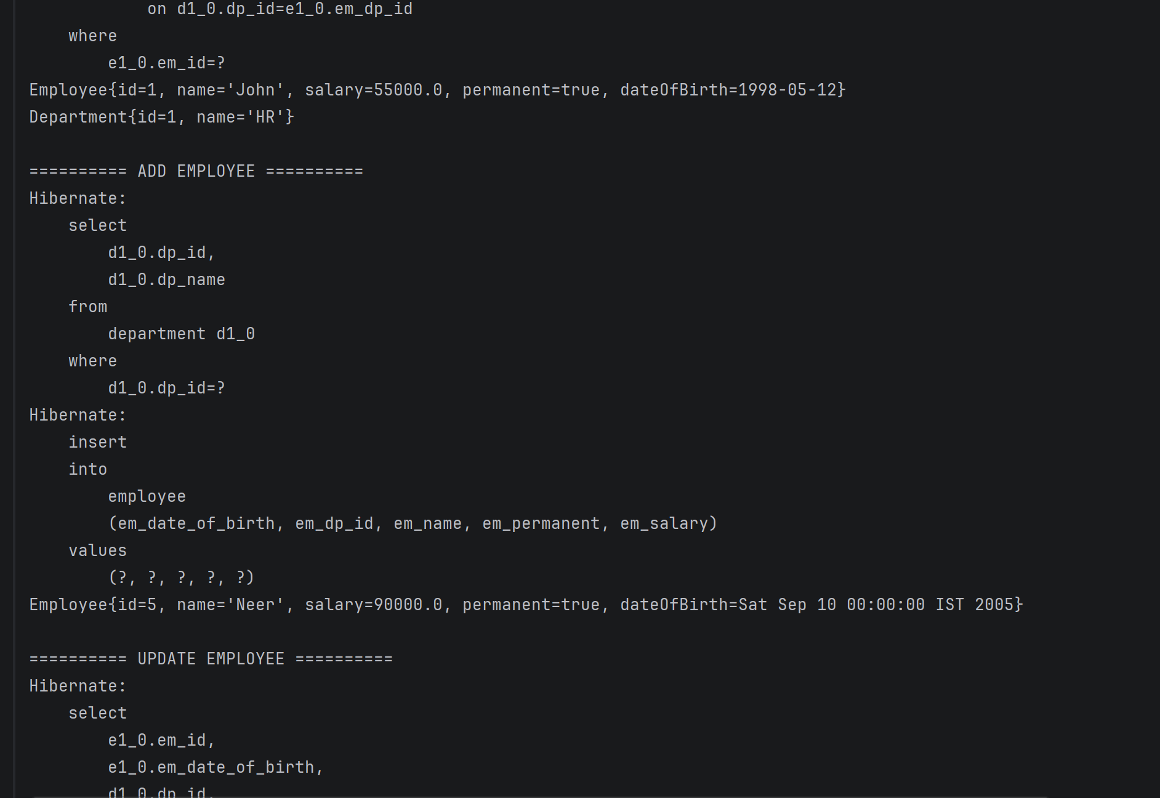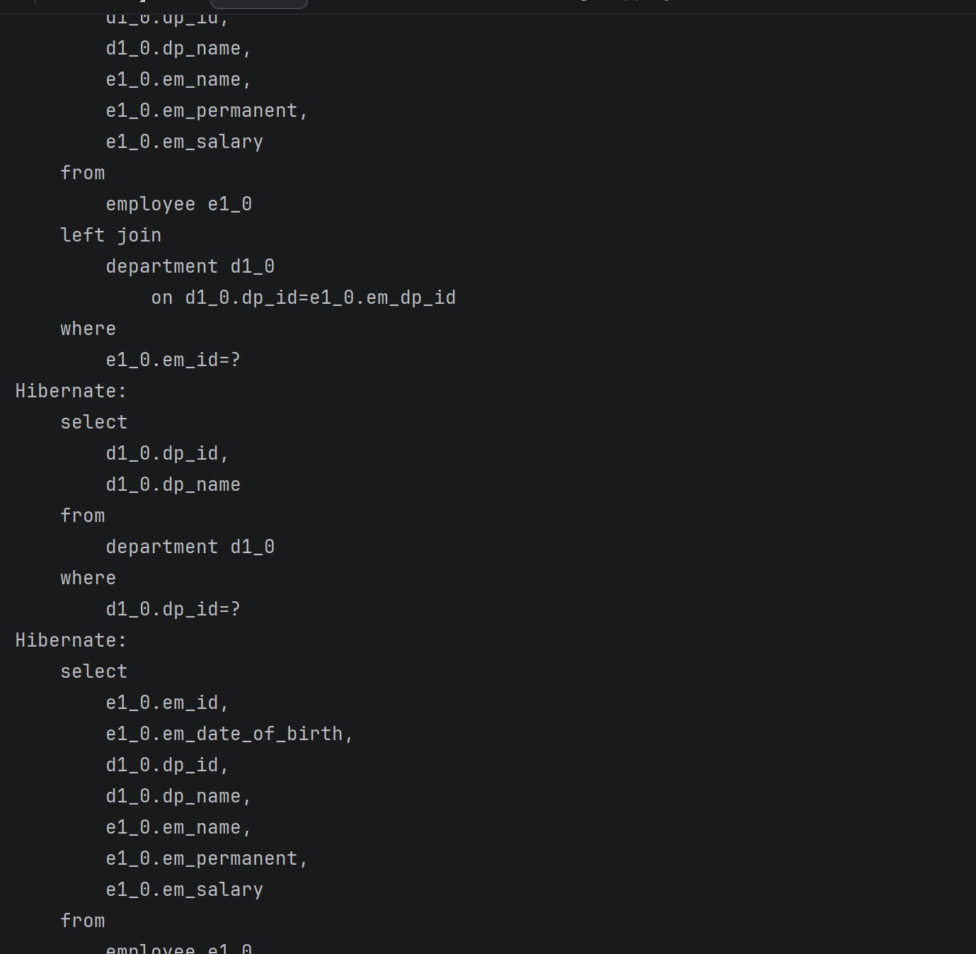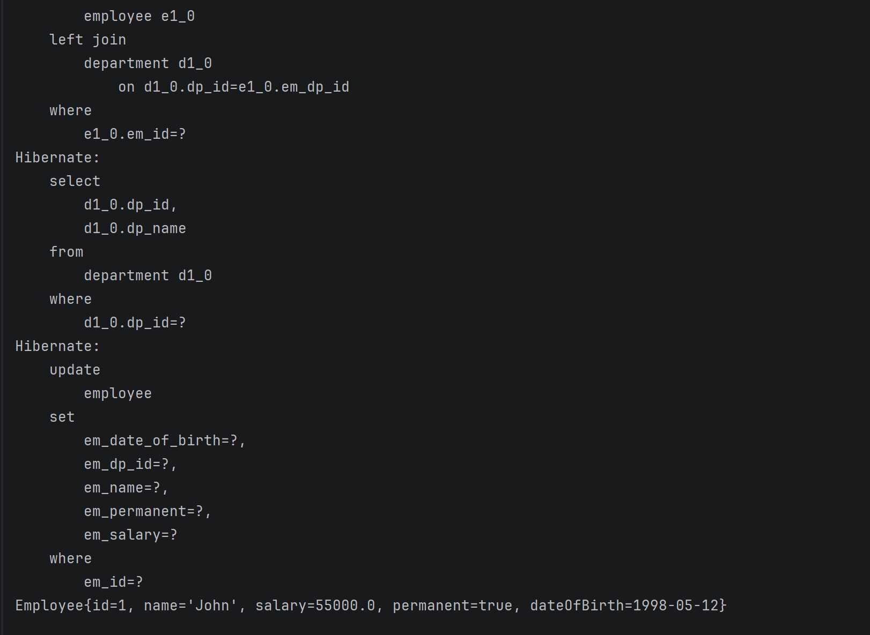

HandsOn 5
Department.java
package com.cognizant.ormlearn.model;
import jakarta.persistence.*;
import java.util.Set;
@Entity
@Table(name = "department")
public class Department {
@Id
@GeneratedValue(strategy = GenerationType.IDENTITY)
@Column(name = "dp_id")
private int id;
@Column(name = "dp_name")
private String name;
@OneToMany(mappedBy = "department", fetch = FetchType.EAGER)
private Set<Employee> employeeList;
public Department() {
}
public int getId() {
return id;
}
public void setId(int id) {
this.id = id;
}
public String getName() {
return name;
}
public void setName(String name) {
this.name = name;
}
public Set<Employee> getEmployeeList() {
return employeeList;
}
public void setEmployeeList(Set<Employee> employeeList) {
this.employeeList = employeeList;
}
@Override
public String toString() {
return "Department{" +
"id=" + id +
", name='" + name + '\'' +
'}';
}
}

OrmLearnApplication.java
package com.cognizant.ormlearn;
import com.cognizant.ormlearn.model.Department;
import com.cognizant.ormlearn.model.Employee;
import com.cognizant.ormlearn.repository.CountryRepository;
import com.cognizant.ormlearn.repository.StockRepository;
import com.cognizant.ormlearn.service.DepartmentService;
import com.cognizant.ormlearn.service.EmployeeService;
import com.cognizant.ormlearn.service.SkillService;
import org.springframework.beans.factory.annotation.Autowired;
import org.springframework.boot.CommandLineRunner;
import org.springframework.boot.SpringApplication;
import org.springframework.boot.autoconfigure.SpringBootApplication;
import org.springframework.context.annotation.Bean;
import java.math.BigDecimal;
import java.text.SimpleDateFormat;
import java.time.LocalDate;
@SpringBootApplication
public class OrmLearnApplication {
@Autowired
private EmployeeService employeeService;
@Autowired
private DepartmentService departmentService;
@Autowired
private SkillService skillService;
public static void main(String[] args) {
SpringApplication.run(OrmLearnApplication.class, args);
}
@Bean
CommandLineRunner run(CountryRepository countryRepository,
StockRepository stockRepository) {
return args -> {
System.out.println("\n========== COUNTRY ==========");
countryRepository.findByNameContaining("ou").forEach(System.out::println);
countryRepository.findByNameContainingOrderByNameAsc("ou").forEach(System.out::println);
countryRepository.findByNameStartingWith("Z").forEach(System.out::println);
System.out.println("\n========== STOCK ==========");
stockRepository.findByCodeAndDateBetween(
"FB",
LocalDate.of(2019,9,1),
LocalDate.of(2019,9,30))
.forEach(System.out::println);
stockRepository.findByCodeAndCloseGreaterThan(
"GOOGL",
new BigDecimal("1250"))
.forEach(System.out::println);
stockRepository.findTop3ByOrderByVolumeDesc()
.forEach(System.out::println);
stockRepository.findTop3ByCodeOrderByCloseAsc("NFLX")
.forEach(System.out::println);
testGetEmployee();
testAddEmployee();
testUpdateEmployee();
testGetDepartment();
};
}
private void testGetEmployee() {
Employee employee = employeeService.get(1);
System.out.println(employee);
System.out.println(employee.getDepartment());
}
private void testAddEmployee() throws Exception {
Employee employee = new Employee();
employee.setName("Neer");
employee.setSalary(90000);
employee.setPermanent(true);
employee.setDateOfBirth(
new SimpleDateFormat("dd/MM/yyyy")
.parse("10/09/2005"));
Department department = departmentService.get(2);
employee.setDepartment(department);
employeeService.save(employee);
}
private void testUpdateEmployee() {
Employee employee = employeeService.get(1);
Department department = departmentService.get(3);
employee.setDepartment(department);
employeeService.save(employee);
}
private void testGetDepartment() {
System.out.println("\n========== GET DEPARTMENT ==========");
Department department = departmentService.get(2);
System.out.println(department);
System.out.println(department.getEmployeeList());
}
}

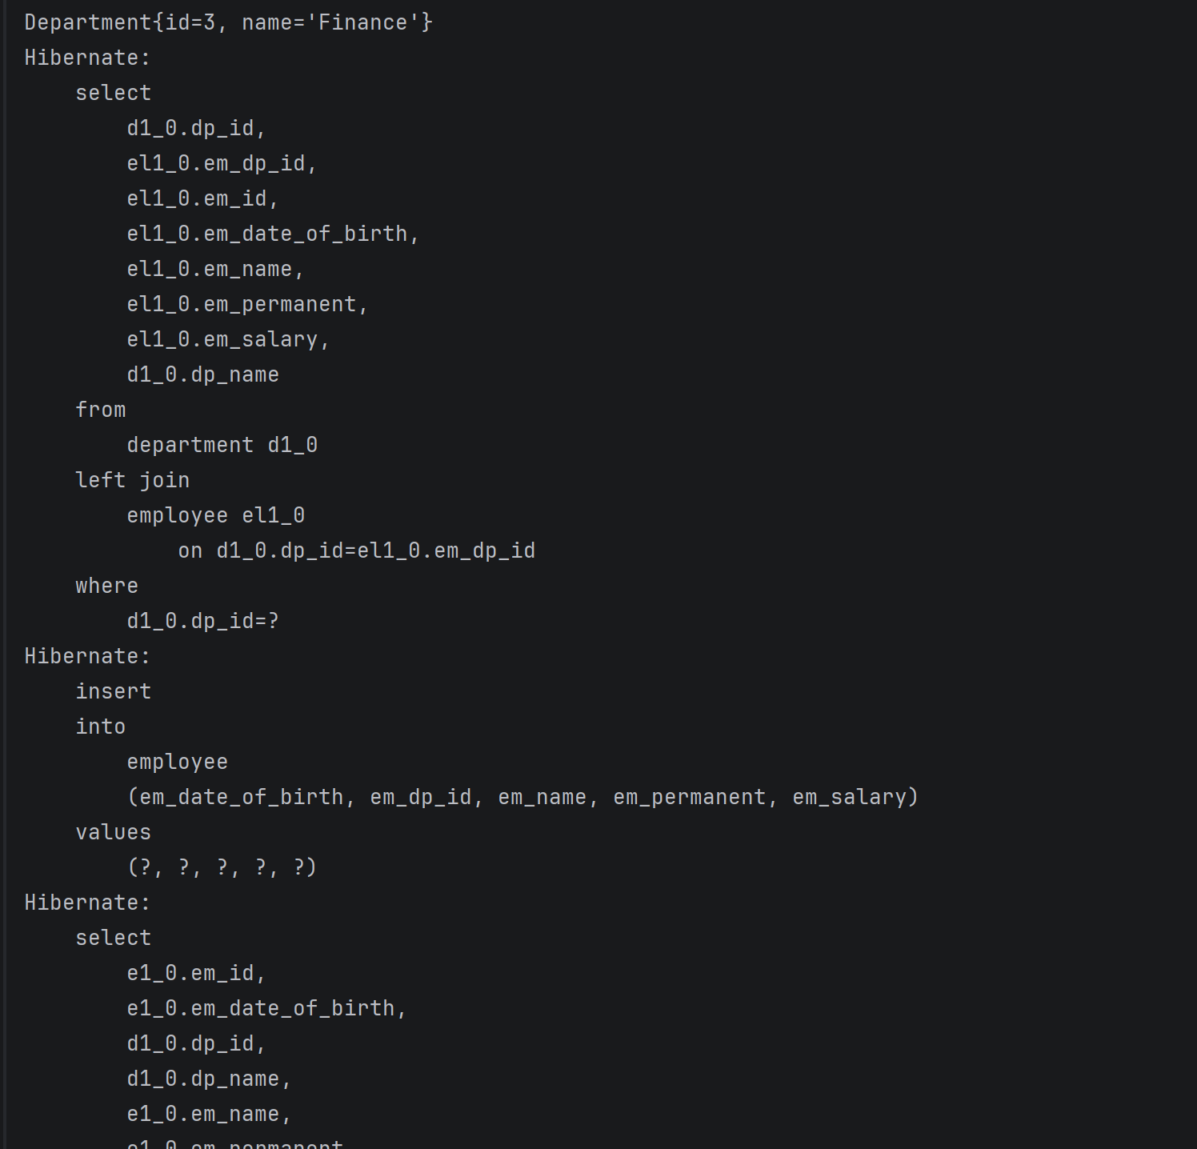
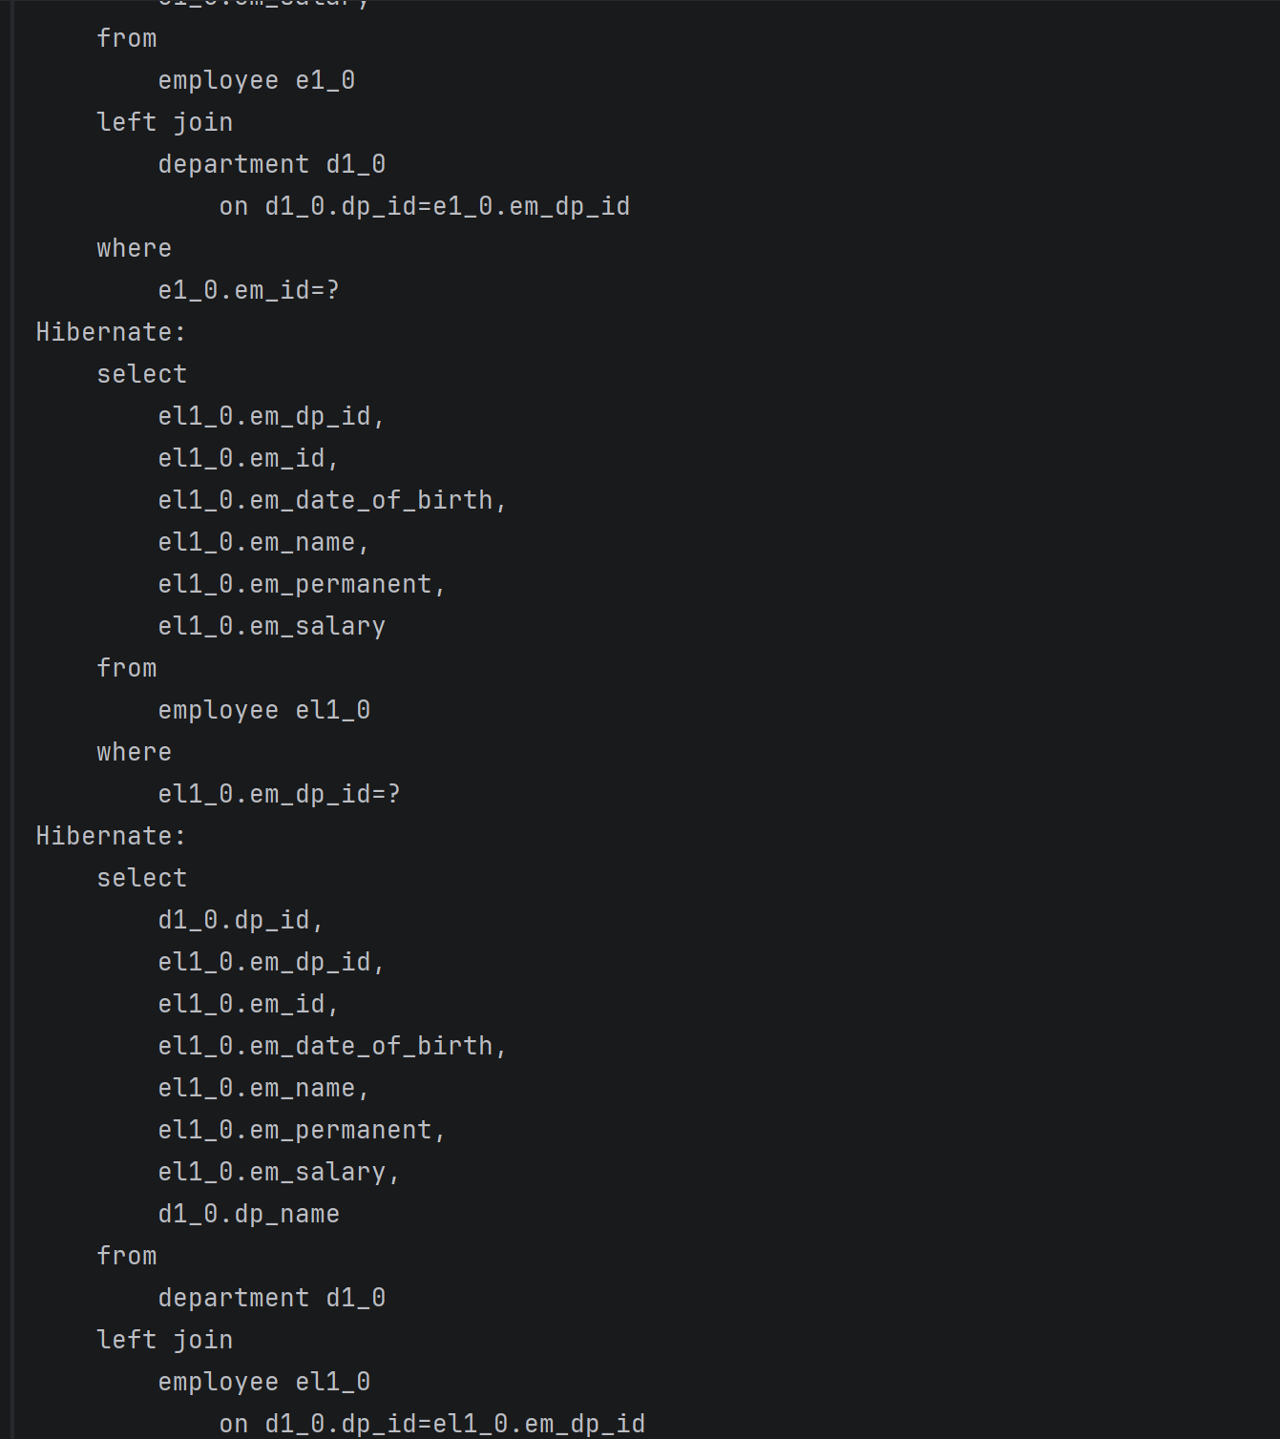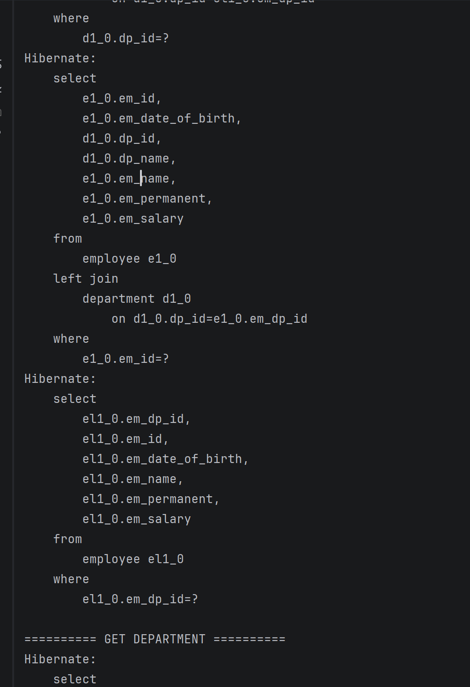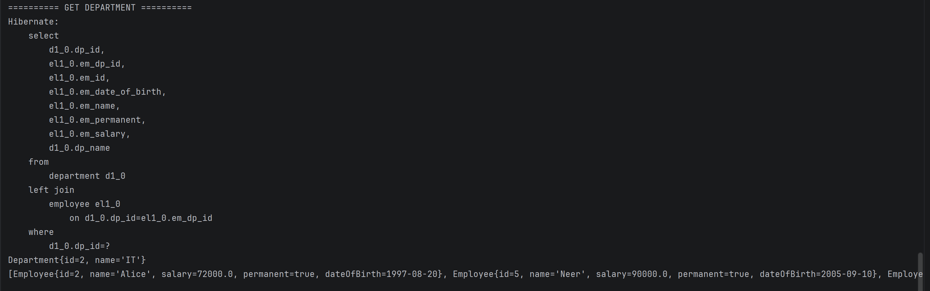

HandsOn6
Employee.java
package com.cognizant.ormlearn.model;
import jakarta.persistence.*;
import java.util.Date;
import java.util.Set;
@Entity
@Table(name = "employee")
public class Employee {
@Id
@GeneratedValue(strategy = GenerationType.IDENTITY)
@Column(name = "em_id")
private int id;
@Column(name = "em_name")
private String name;
@Column(name = "em_salary")
private double salary;
@Column(name = "em_permanent")
private boolean permanent;
@Temporal(TemporalType.DATE)
@Column(name = "em_date_of_birth")
private Date dateOfBirth;
@ManyToOne
@JoinColumn(name = "em_dp_id")
private Department department;
@ManyToMany(fetch = FetchType.EAGER)
@JoinTable(
name = "employee_skill",
joinColumns = @JoinColumn(name = "es_em_id"),
inverseJoinColumns = @JoinColumn(name = "es_sk_id")
)
private Set<Skill> skillList;
public Employee() {
}
public int getId() {
return id;
}
public void setId(int id) {
this.id = id;
}
public String getName() {
return name;
}
public void setName(String name) {
this.name = name;
}
public double getSalary() {
return salary;
}
public void setSalary(double salary) {
this.salary = salary;
}
public boolean isPermanent() {
return permanent;
}
public void setPermanent(boolean permanent) {
this.permanent = permanent;
}
public Date getDateOfBirth() {
return dateOfBirth;
}
public void setDateOfBirth(Date dateOfBirth) {
this.dateOfBirth = dateOfBirth;
}
public Department getDepartment() {
return department;
}
public void setDepartment(Department department) {
this.department = department;
}
public Set<Skill> getSkillList() {
return skillList;
}
public void setSkillList(Set<Skill> skillList) {
this.skillList = skillList;
}
@Override
public String toString() {
return "Employee{" +
"id=" + id +
", name='" + name + '\'' +
", salary=" + salary +
", permanent=" + permanent +
", dateOfBirth=" + dateOfBirth +
'}';
}
}

Skill.java
package com.cognizant.ormlearn.model;
import jakarta.persistence.*;
import java.util.Set;
@Entity
@Table(name = "skill")
public class Skill {
@Id
@GeneratedValue(strategy = GenerationType.IDENTITY)
@Column(name = "sk_id")
private int id;
@Column(name = "sk_name")
private String name;
@ManyToMany(mappedBy = "skillList")
private Set<Employee> employeeList;
public Skill() {
}
public int getId() {
return id;
}
public void setId(int id) {
this.id = id;
}
public String getName() {
return name;
}
public void setName(String name) {
this.name = name;
}
public Set<Employee> getEmployeeList() {
return employeeList;
}
public void setEmployeeList(Set<Employee> employeeList) {
this.employeeList = employeeList;
}
@Override
public String toString() {
return "Skill{" +
"id=" + id +
", name='" + name + '\'' +
'}';
}
}
OrmLearnApplication.java
package com.cognizant.ormlearn;
import com.cognizant.ormlearn.model.Department;
import com.cognizant.ormlearn.model.Employee;
import com.cognizant.ormlearn.model.Skill;
import com.cognizant.ormlearn.repository.CountryRepository;
import com.cognizant.ormlearn.repository.StockRepository;
import com.cognizant.ormlearn.service.DepartmentService;
import com.cognizant.ormlearn.service.EmployeeService;
import com.cognizant.ormlearn.service.SkillService;
import org.springframework.beans.factory.annotation.Autowired;
import org.springframework.boot.CommandLineRunner;
import org.springframework.boot.SpringApplication;
import org.springframework.boot.autoconfigure.SpringBootApplication;
import org.springframework.context.annotation.Bean;
import java.math.BigDecimal;
import java.text.SimpleDateFormat;
import java.time.LocalDate;
@SpringBootApplication
public class OrmLearnApplication {
@Autowired
private EmployeeService employeeService;
@Autowired
private DepartmentService departmentService;
@Autowired
private SkillService skillService;
public static void main(String[] args) {
SpringApplication.run(OrmLearnApplication.class, args);
}
@Bean
CommandLineRunner run(CountryRepository countryRepository,
StockRepository stockRepository) {
return args -> {
// =======================
// HANDS ON 1
// =======================
System.out.println("\n========== COUNTRY ==========");
System.out.println("\nCountries containing 'ou'");
countryRepository.findByNameContaining("ou")
.forEach(System.out::println);
System.out.println("\nCountries containing 'ou' in ascending order");
countryRepository.findByNameContainingOrderByNameAsc("ou")
.forEach(System.out::println);
System.out.println("\nCountries starting with 'Z'");
countryRepository.findByNameStartingWith("Z")
.forEach(System.out::println);
// =======================
// HANDS ON 2
// =======================
System.out.println("\n========== STOCK ==========");
System.out.println("\nFacebook September Data");
stockRepository.findByCodeAndDateBetween(
"FB",
LocalDate.of(2019, 9, 1),
LocalDate.of(2019, 9, 30))
.forEach(System.out::println);
System.out.println("\nGoogle Close > 1250");
stockRepository.findByCodeAndCloseGreaterThan(
"GOOGL",
new BigDecimal("1250"))
.forEach(System.out::println);
System.out.println("\nTop 3 Highest Volume");
stockRepository.findTop3ByOrderByVolumeDesc()
.forEach(System.out::println);
System.out.println("\nLowest Netflix");
stockRepository.findTop3ByCodeOrderByCloseAsc("NFLX")
.forEach(System.out::println);
// =======================
// HANDS ON 4
// =======================
testGetEmployee();
testAddEmployee();
testUpdateEmployee();
// =======================
// HANDS ON 5
// =======================
testGetDepartment();
// =======================
// HANDS ON 6
// =======================
testAddSkillToEmployee();
};
}
private void testGetEmployee() {
System.out.println("\n========== GET EMPLOYEE ==========");
Employee employee = employeeService.get(1);
System.out.println(employee);
System.out.println(employee.getDepartment());
System.out.println(employee.getSkillList());
}
private void testAddEmployee() throws Exception {
System.out.println("\n========== ADD EMPLOYEE ==========");
Employee employee = new Employee();
employee.setName("Neer");
employee.setSalary(90000);
employee.setPermanent(true);
employee.setDateOfBirth(
new SimpleDateFormat("dd/MM/yyyy")
.parse("10/09/2005"));
Department department = departmentService.get(2);
employee.setDepartment(department);
employeeService.save(employee);
System.out.println(employee);
}
private void testUpdateEmployee() {
System.out.println("\n========== UPDATE EMPLOYEE ==========");
Employee employee = employeeService.get(1);
Department department = departmentService.get(3);
employee.setDepartment(department);
employeeService.save(employee);
System.out.println(employee);
}
private void testGetDepartment() {
System.out.println("\n========== GET DEPARTMENT ==========");
Department department = departmentService.get(2);
System.out.println(department);
System.out.println(department.getEmployeeList());
}
private void testAddSkillToEmployee() {
System.out.println("\n========== ADD SKILL TO EMPLOYEE ==========");
Employee employee = employeeService.get(3);
Skill skill = skillService.get(1);
employee.getSkillList().add(skill);
employeeService.save(employee);
System.out.println(employee.getSkillList());
}
}

Output
